Values & Variables

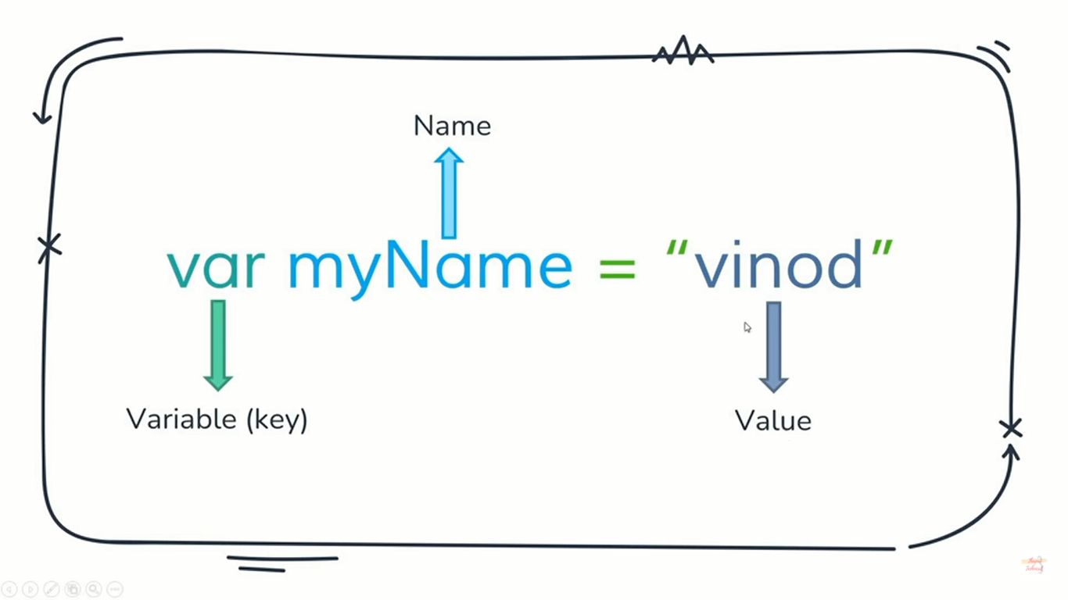

* The first character must be a letter or an underscore (_) or an dollar($). You can’t use a number as the first character.  
  For Ex: $myName
* The rest of the variable name can include any letter, any number, or the underscore. Can’t use any other characters, including spaces.  
  Ex. Of Wrong variable: 1myName, my Name, $myName% etc.
* Variable names are case sensitive.
* No limit to the length of the variable name.
* We can’t use one of JS’s reserved words as a variable name.  
  For ex: we can’t use var as a variable name because it’s a javascript’s reserved word.